Unit 1 | Introducing Science
Topic: What factors affect melting of ice?
Worksheet
Name: _______________
Class: ____________( )
Date: ________________

Task

PART (A)
The following materials and apparatus are available.
Distilled water (or tap water), sugar, salt, beaker, spatula, measuring cylinder, glass rod, weighing scale, ice rack, label sticker, refrigerator

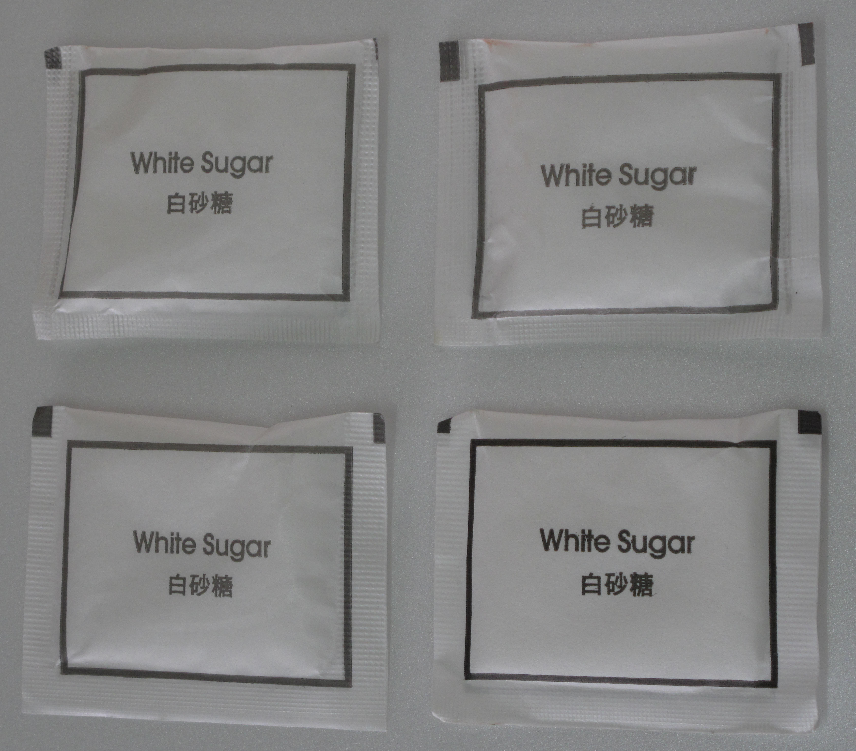  Sugar | 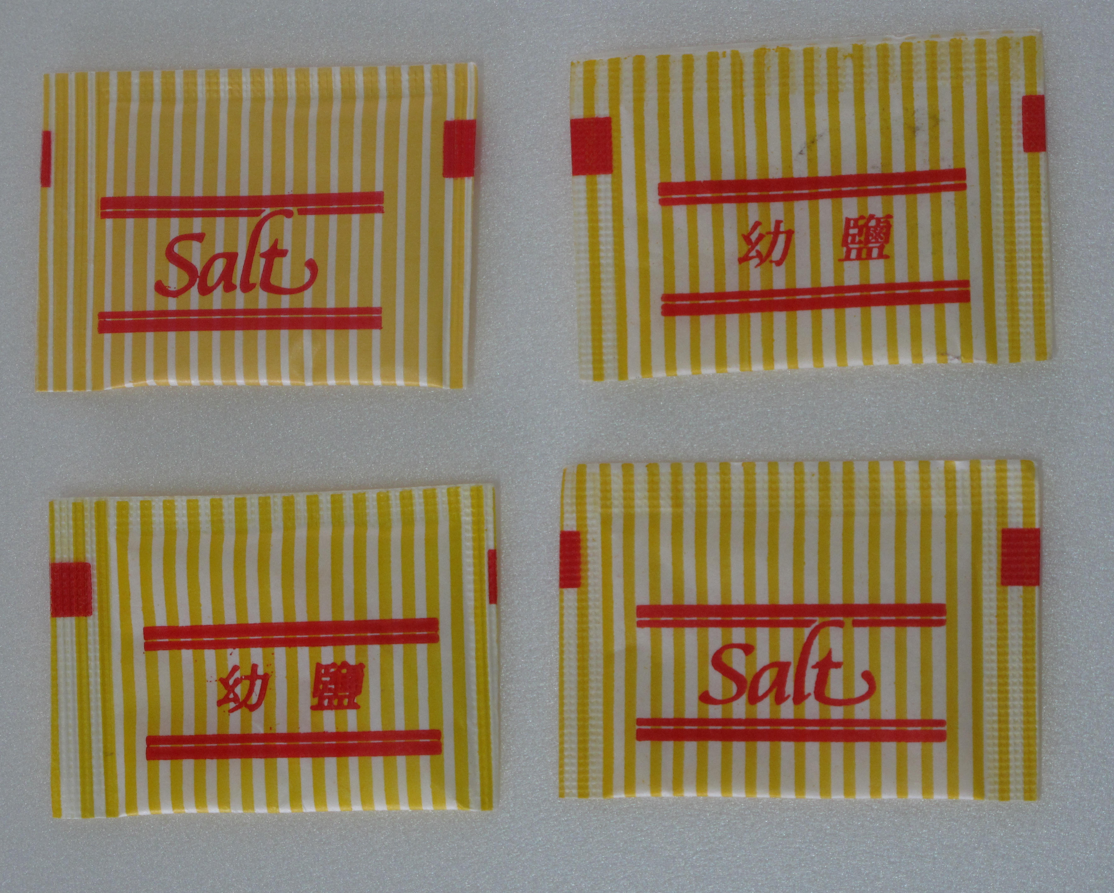  Salt | 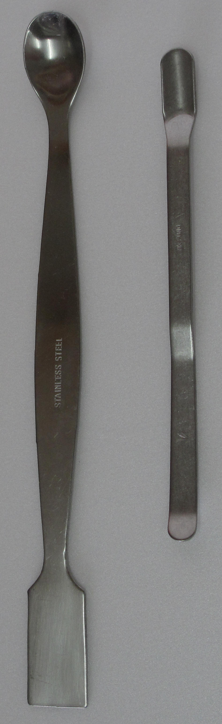  Spatula | 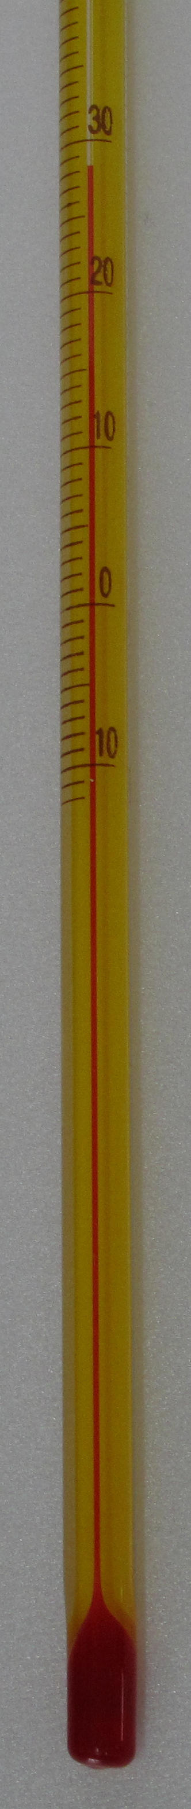  Thermometer
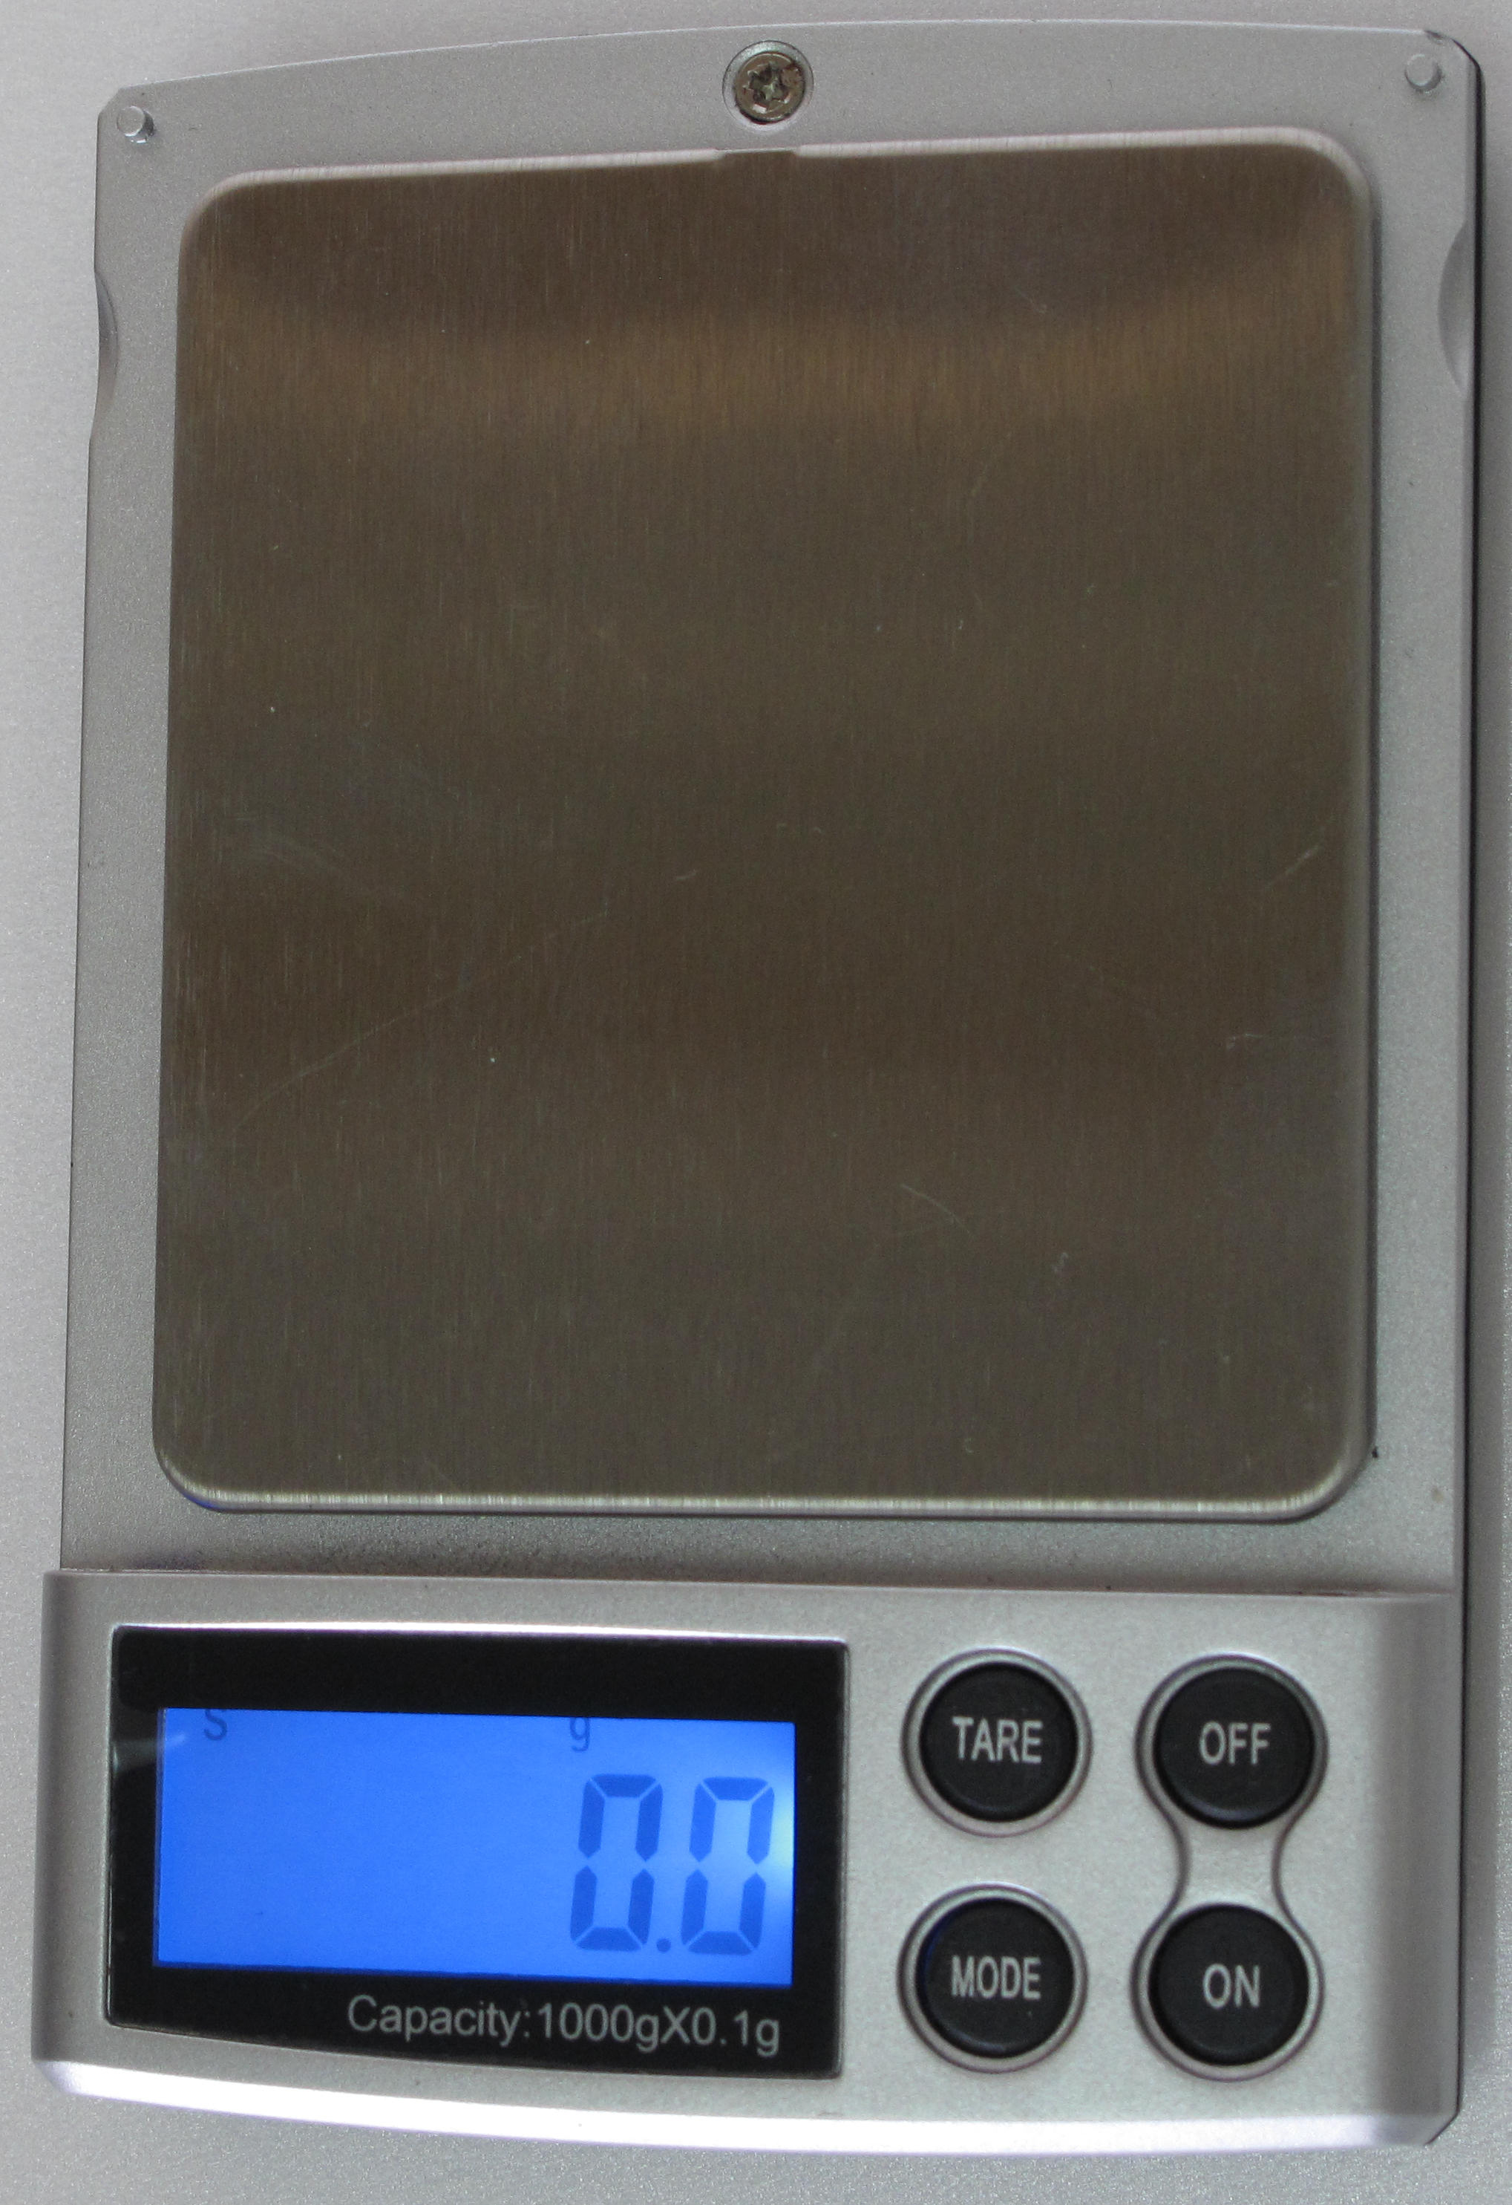  Weighing scale | 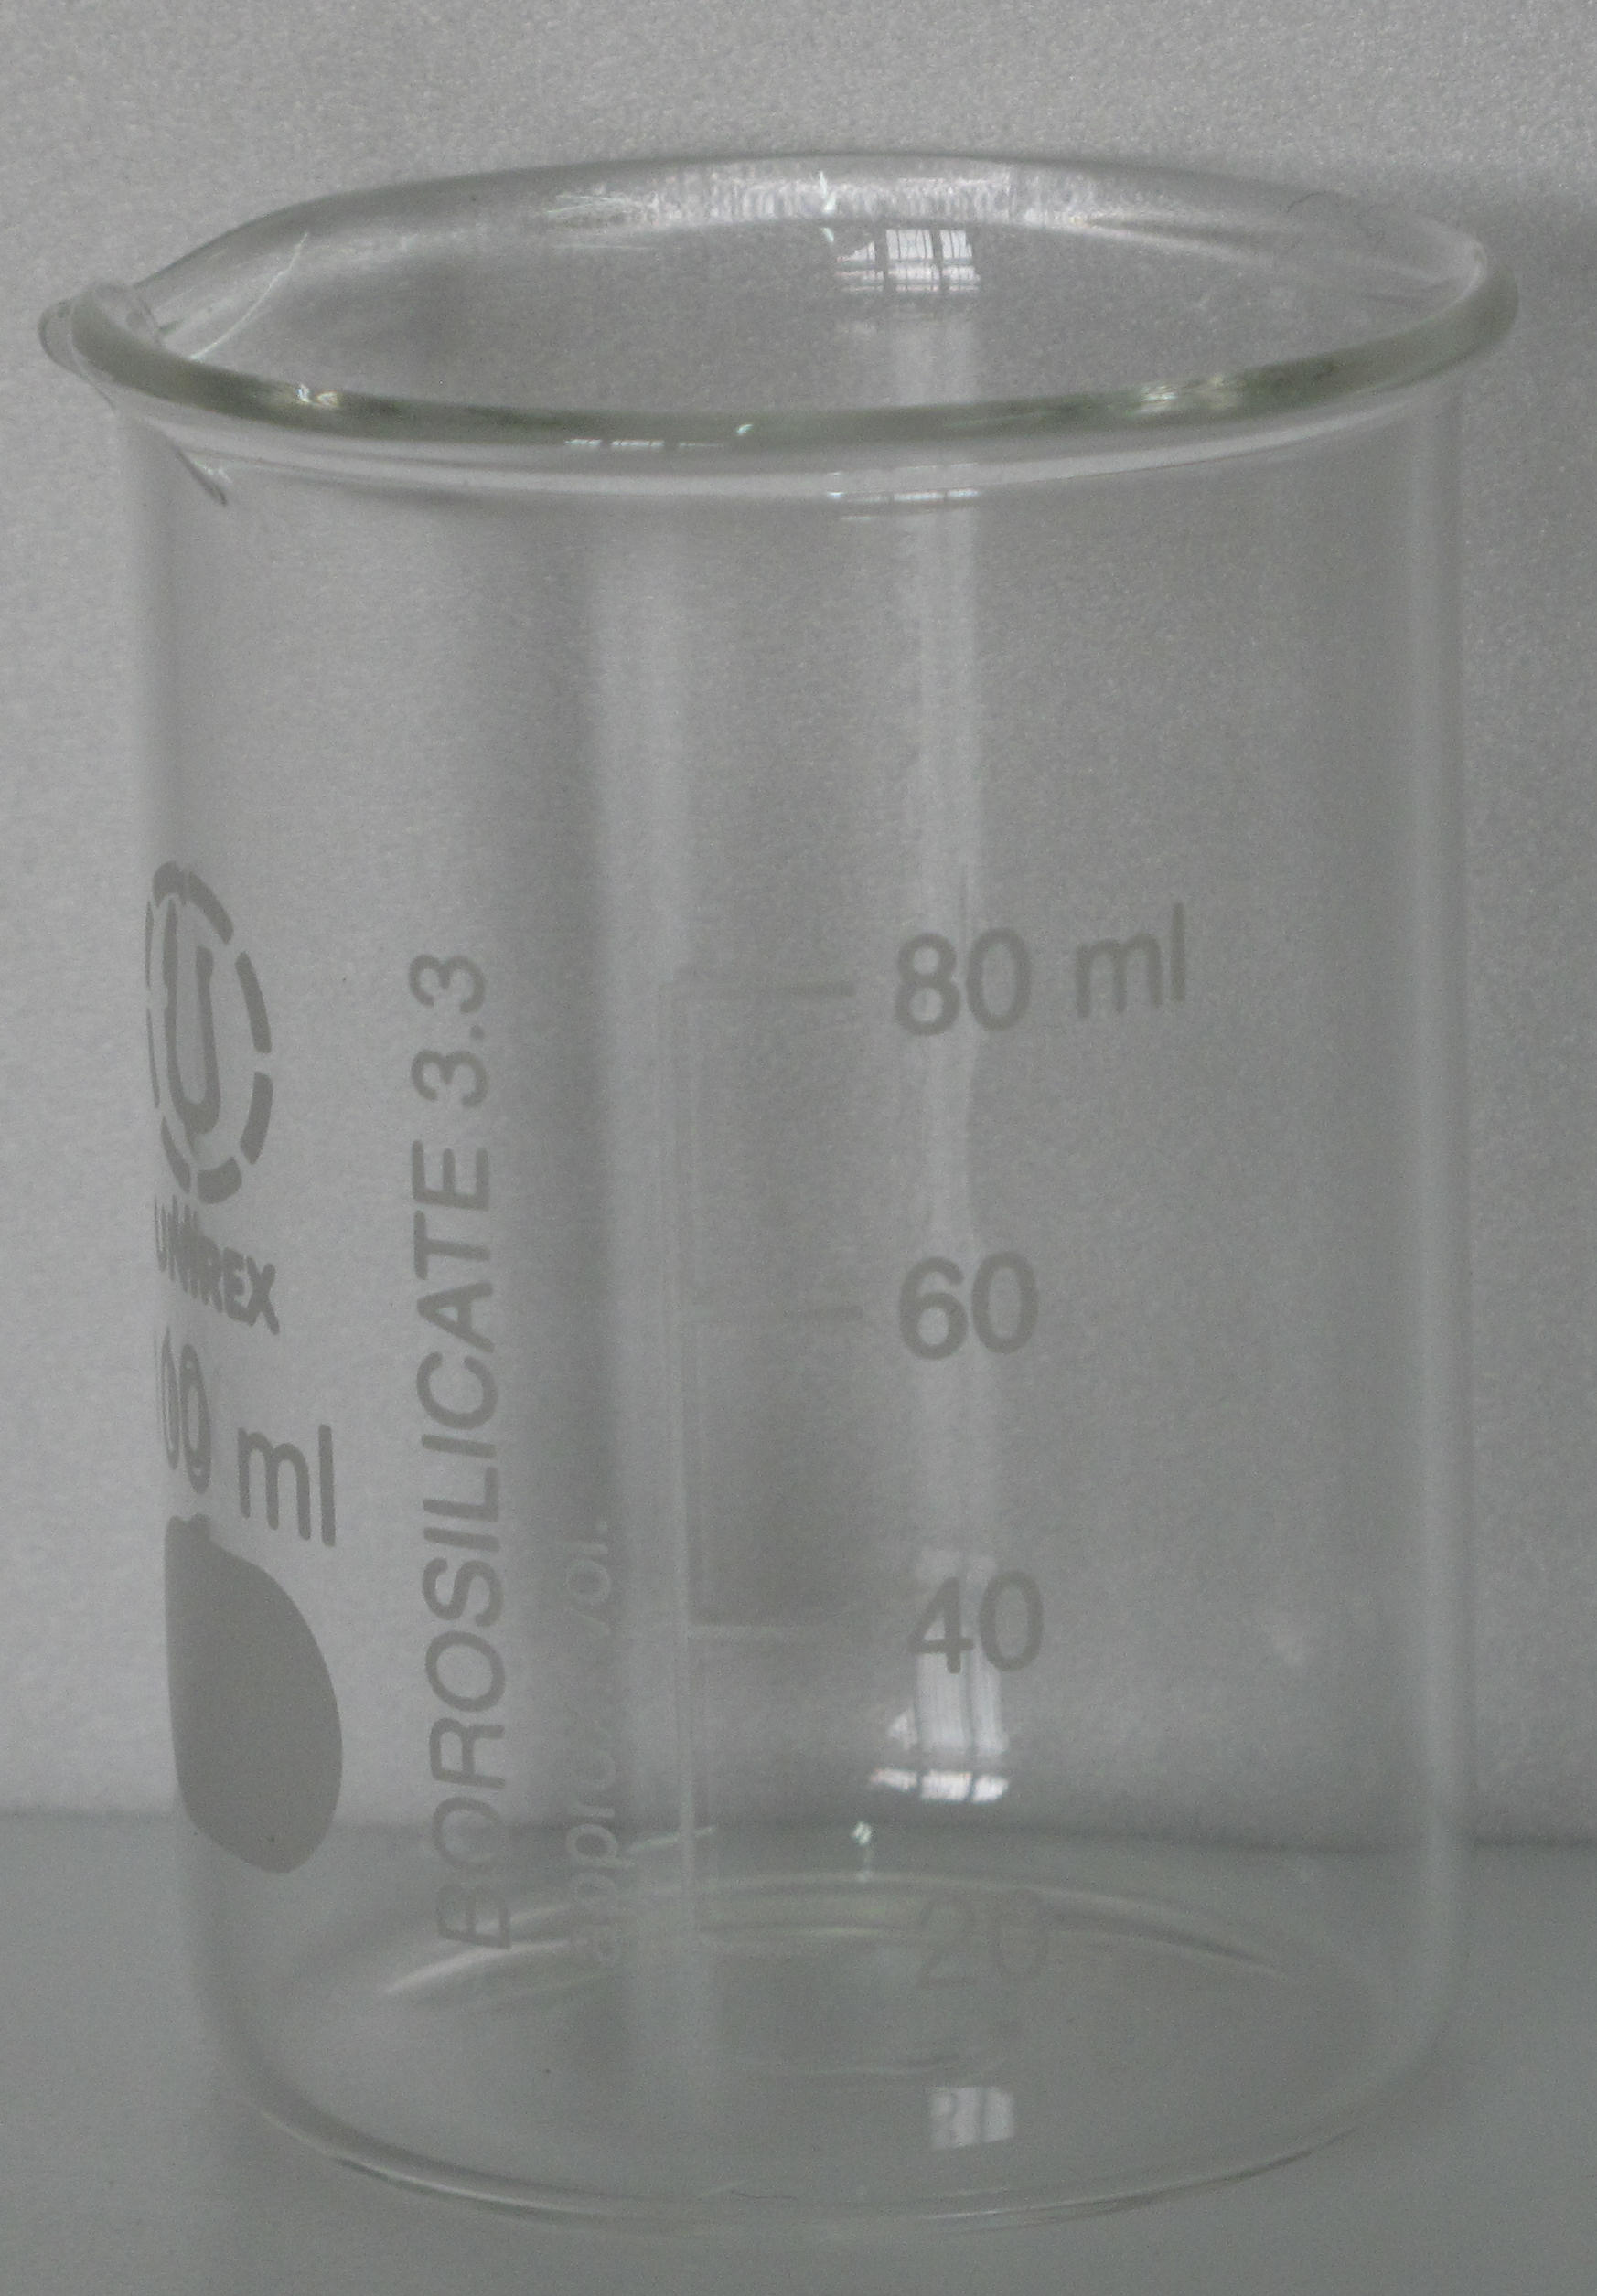  Beaker
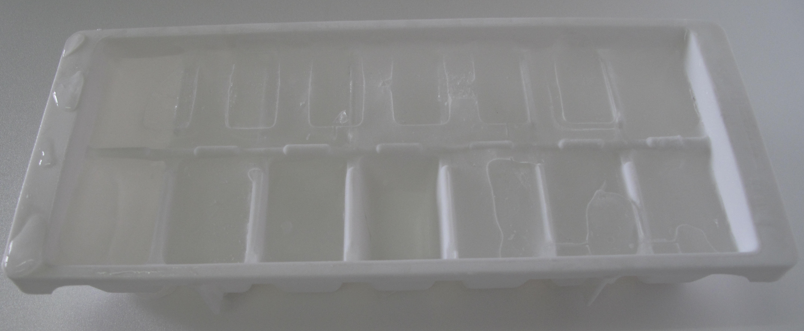
Ice rack
In PART (B) of this investigation, you are going to measure the time it takes for ice cubes made respectively from water, sugar solution and salt solution to melt completely. In PART (A) here, you have to prepare these ice cubes.

1. In order to carry out a fair test in PART (B), suggest some variables of physical quantities that have to be considered when making the ice cubes.

2. Describe how to prepare solutions of sugar and salt of the same concentration.

3. Describe the procedures and the uses of suitable apparatus to make ice cubes for fair tests in PART (B).

PART (B)
Stop watch, ice cubes in ice rack made in PART (A), thermometers

1. Which is the better way to leave the ice cubes to melt, removing them from the ice rack and putting them into a suitable container or leaving them melting in the ice rack? Explain briefly.

2. Fill in the following brackets with correct unit. When the ice cubes are melting, put a thermometer into each melting ice cube. What do you observe about the temperature? Record your observation at regular intervals until the ice cubes completely melt.

Solution/Liquid: Water
Time ( )
Temperature (°C)

Solution/Liquid: Sugar solution Concentration: __________ ( )
Time ( )
Temperature (°C)

Solution/Liquid: Salt solution Concentration: __________ ( )
Time ( )
Temperature (°C)
3. What conclusion(s) can be drawn from this part of the investigation?

PART (C)
Stop watch, ice cubes in ice rack made in PART (A), thermometers

1. Repeat PART (A) to prepare ice cubes of a particular solution, but with different concentrations. Then measure the temperature and time for the ice cubes to melt completely. Identify the independent variable and dependent variable in this PART (C).

2. Record your observation at regular intervals until the ice cubes completely melt.

Solution/Liquid: _________________ Concentration: __________ ( )
Time ( )
Temperature (°C)

Solution/Liquid: _________________ Concentration: __________ ( )
Time ( )
Temperature (°C)

Solution/Liquid: _________________ Concentration: __________ ( )
Time ( )
Temperature (°C)

Solution/Liquid: _________________ Concentration: __________ ( )
Time ( )
Temperature (°C)

Solution/Liquid: _________________ Concentration: __________ ( )
Time ( )
Temperature (°C)

3. What conclusion(s) can be drawn from this part of the investigation?

4. Predict the result(s) if the investigation is repeated with another solution.

